**Final Presentation**

Turn your final paper into a 10-minute presentation.

1. Your presentation should be between 10-15 slides
2. Record your presentation and post to the google classroom
   1. This can be done using screencastomatic (<https://screencast-o-matic.com/>) or zoom
3. Watch 3 presentations by other classmates and answer the following questions.
   1. Presenter
   2. What was the design?
   3. Could you identify the model of the design?
   4. What was the null hypothesis?
   5. What was the experiment unit?
   6. Was there a visualization that helped you understand the model?
   7. What were the conclusions?
   8. Does the model/data support the conclusions?

**You need to upload your presentation twice once to the homework and once to the main feed. To upload to the main feed please follow the steps below.**

1. **Open the main comment feed to the main section**

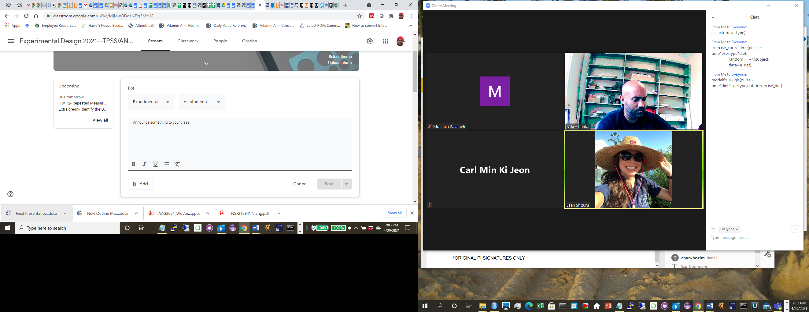

1. **Go to the add button**

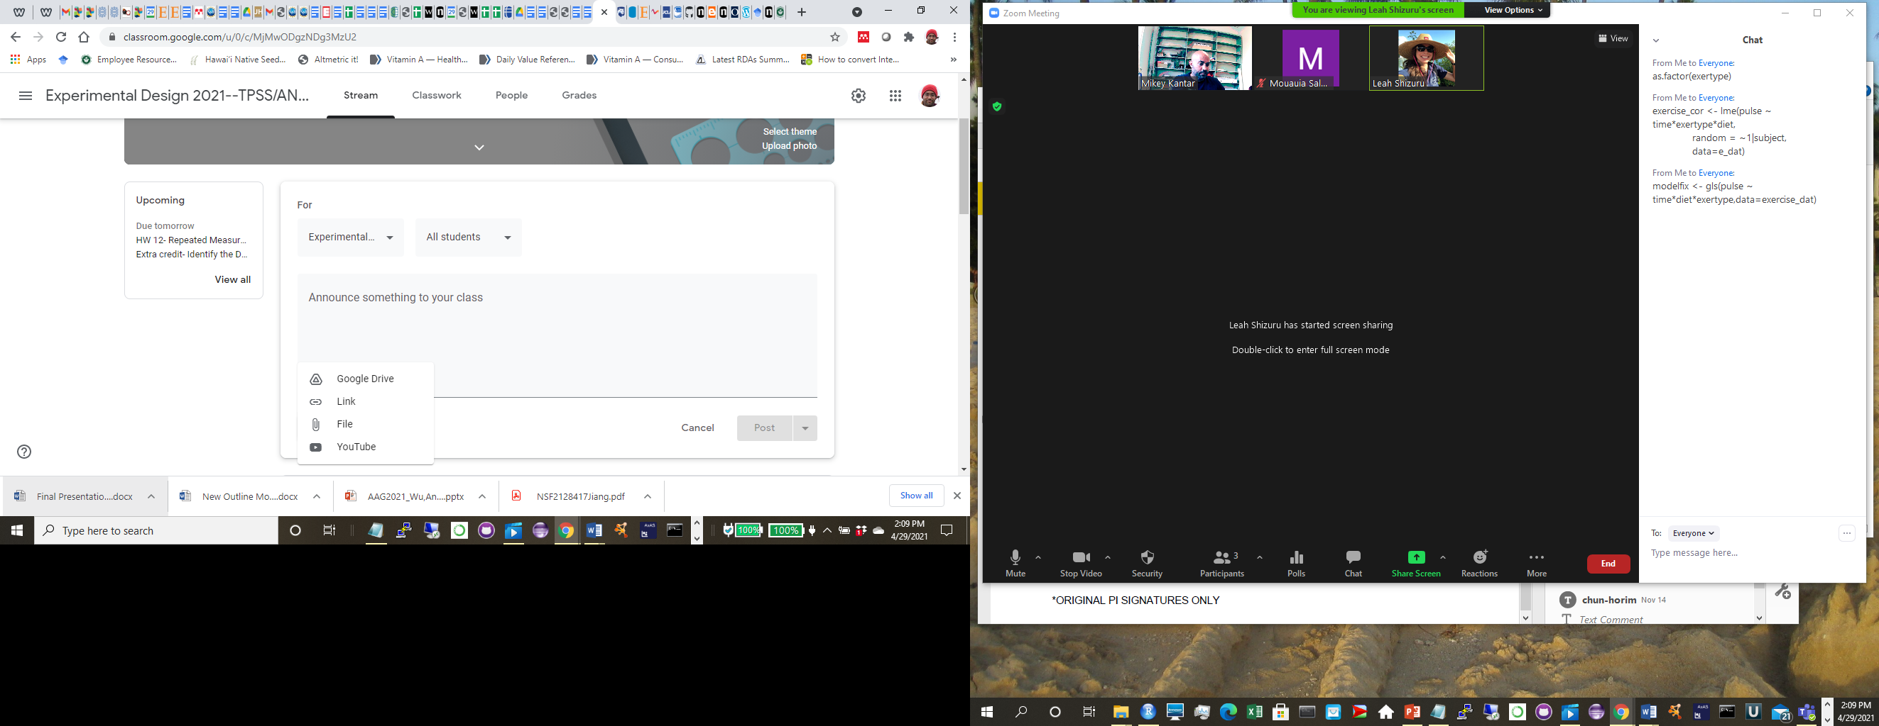

1. **Upload a file**

